Celebrate 25 Years of PNCs
For $20 more get
Plate #6 and support
PNC³ @ Washington 2006
With a
See the reverse side for ordering details.
Polo or T-Shirt
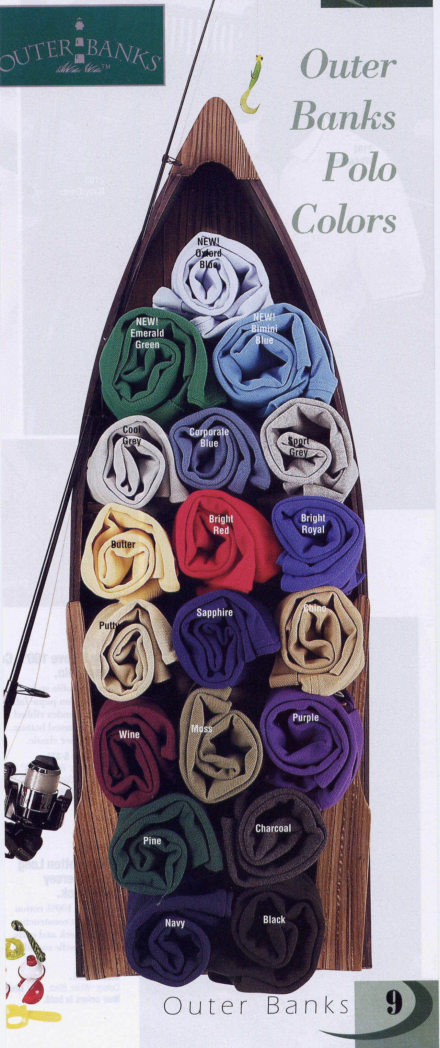
Red Shirt White Letters

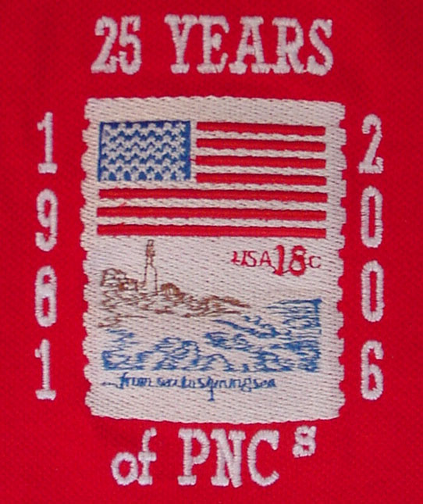

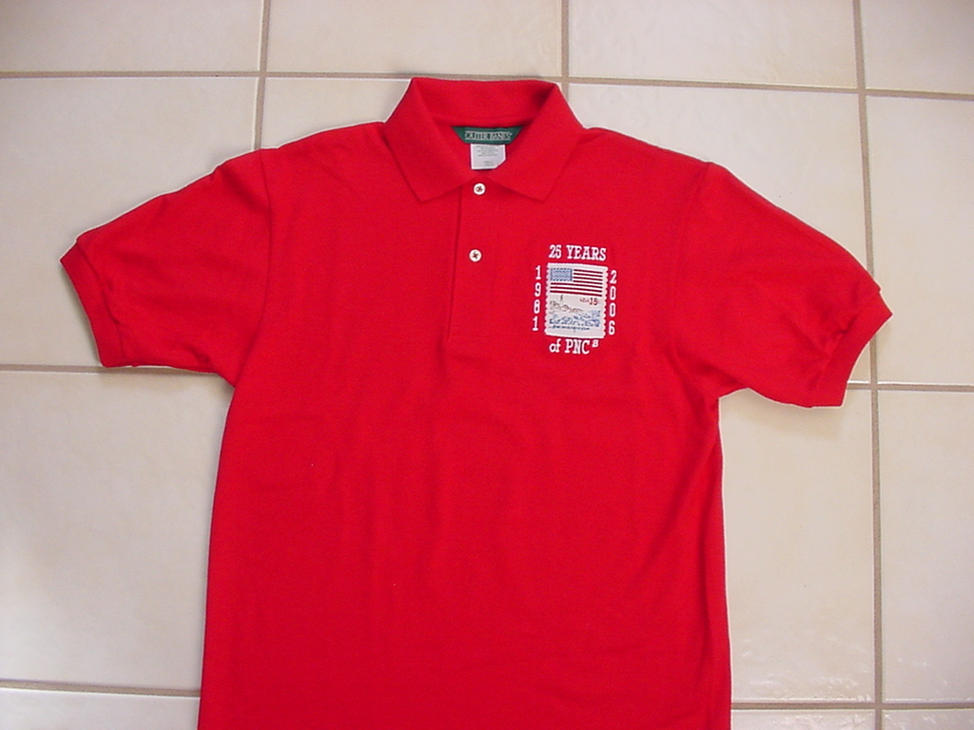

Red Polo Shirt without pocket

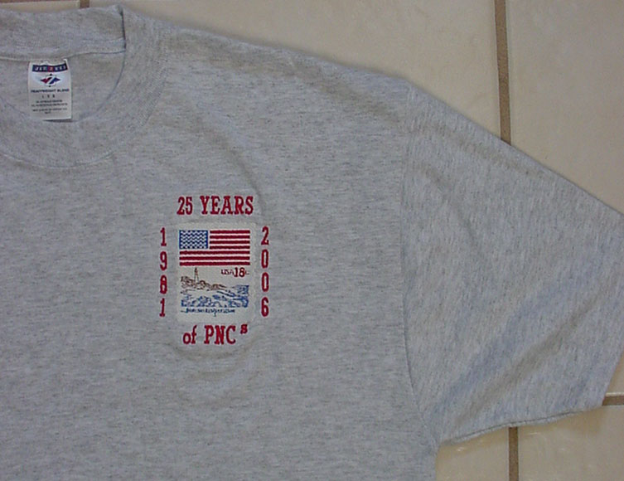
Gray T-shirt
Red Letters

